Guidance to assist DSS and HCSS employers and employees in developing risk assessment processes for vulnerable workers returning to work.

1: Example Risk Assessment process flow chart

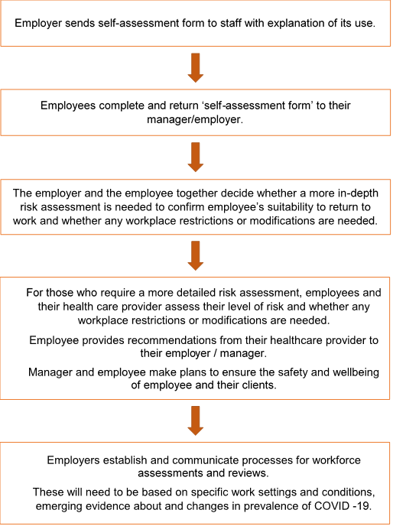

2: Self-Assessment form for high risk employees in home and community support services

Purpose of self-identification and self-assessment
This self-assessment can assist employees to identify any underlying health issues that may need a more detailed assessment to inform whether workplace restrictions or modifications are necessary to protect you, your whanau and your clients.

Self-assessment form for employees who may be at risk
Q. What is the aim of self-assessment?
A. The self-assessment form has been adapted for the disability and aged care sector groups to identify people who are at higher risk if exposed to COVID-19. It considers:
- work location
- health risks of an individual
- other factors that might impact on your safety at work.
The answers you give will help employers identify ways they can support you to remain at work with minimal risk and/or change your current duties where practical.
Q. What will happen to any health information I share?
A. Any personal and/or health information you share will be held in confidence by your employer and not be disclosed without your express permission except for the express purpose of carrying out the risk assessment or as required by law.
Q. How does the self-assessment tool work?
A. You are asked to fill in a self-assessment form and if you answer Yes to the health or age question one of your managers will ring you to discuss your options and wishes.
Q. How will my situation be assessed?
A. In the appendix to the questionnaire the conditions of concern and other risk factors are included. These will be discussed at a phone interview or via a face to face interview.
Q. Who can I get help from to complete this assessment
A. You can get help from your employer, the Health and Safety representative (if there is one) a union representative if you are a member of a union, from a friend or someone else who you trust.

Self – Assessment Form
Please complete and return this form to your Manager
NAME

Employee no

Date of Birth

Contact Mobile number

Contact Email

Job Title

Work area or facility

Current employment status | At work / off work (Please circle which applies to you)
Line Manager

I believe I have a condition that may place me at greater risk from the effects of COVID-19
OR
I am over 70 years of age | YES/NO

For Manager or occupational health representative to complete
Date of assessment

Risks identified

Outcome of assessment | State if safe to work as normal
Actions taken as a result
Date staff member is advised of any decisions

You can get help from your employer, the Health and Safety representative (if there is one) a union representative if you are a member of a union, from a friend or someone else who you trust.

Links to useful information
The following link is to the COVID-19 website and includes guidelines for people at risk of COVID-19.
https://covid19.govt.nz/individuals-and-households/health-and-wellbeing/at-risk-people/#alert-level-2-advice-for-at-risk-people

The following link is to the Ministry of Health website and provides detailed information about pregnancy and the risks of COVID-19.
https://www.health.govt.nz/our-work/diseases-and-conditions/covid-19-novel-coronavirus/covid-19-information-specific-audiences/covid-19-information-pregnant-women-and-those-who-have-recently-given-birth

The following link is to the Ministry of Health website page on Personal Protective Equipment (PPE)
https://www.health.govt.nz/our-work/diseases-and-conditions/covid-19-novel-coronavirus/covid-19-information-specific-audiences/covid-19-personal-protective-equipment-workers

