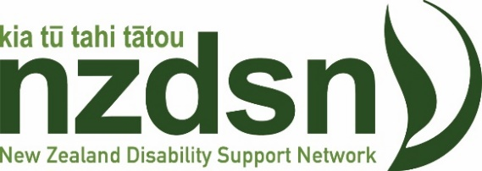

Budget makes progress in fixing disability services underfunding, more needed

Budget 2020 delivers an important catch-up on the long-term underfunding of the disability sector, but there is much more still to do to ensure all disabled New Zealanders and their families get the support they deserve, says New Zealand Disability Support Network CEO Dr Garth Bennie.

“The Budget has lifted support for the disability community to record levels. This will make a real difference in people’s lives after years of funding falling behind the cost of delivering disability support services. However, more will be needed to address the $574m a year funding shortfall in the sector, as calculated by NZDSN in our 2020 Sector Briefing.

“After accounting changes, Budget 2020 represents approximately a $230m a year increase in funding for disability services across Ministry of Health and Ministry of Social Development funded disability services compared to Budget 2019, as well as $104m in disability support catch-up funding for the 2019/20 year. The $230m boost in this Budget equates to the $210m funding shortfall for disability support services, which NZDSN calculated was needed to meet the cost of services for those already in the system. So this is good news.

“This extra funding will help providers pay for the level of services they are currently delivering. We look forward to further details on how the money will be allocated within the sector.

“However, our analysis also shows there around 15,000 people who don’t get the supports they are entitled to because the system does not have capacity and has to ration support, are not available where people live, or do not meet their needs. Increasing demand from this group will continue to put pressure on the service system. Ensuring those people get the help they need should be a priority for the Government. Our analysis shows that would require a further $350m a year in additional funding, on top of what is in this Budget.

“Ministers Salesa and Sepuloni and their government colleagues have been receptive to our calls for more funding for the disability community. This Budget makes a very important commitment to the sector. We look forward to working with the Government to ensure this money is invested well, and is followed by further increases in the future,” said Dr Bennie.

Dr Garth Bennie
Chief Executive

Email: garth@nzdsn.org.nz
Tel - 04 473 4678 / Mobile – 027 673 4678

P O Box 2653 Level 8/86-90 Lambton Quay
Wellington 6140 Wellington 6011
New Zealand Disability Support Network (NZDSN) - Home

