Initial analysis of Disability Funding in Budget 2020

National Disabilities Support Services Budget
Budget 2020 includes a $1.707b allocation for National Disability Support Services in the 20/21 fiscal year, compared to $1.345b allocated in Budget 2019 for 19/20.
After fiscally neutral accounting changes for pay equity and child development services that saw $139m and $8.75m respectively allocated to DSS, and the addition of $104m of funding for Living Good Lives, the total spend for 19/20 is projected to be 1.599b.
Putting aside the transfers, the actual increase in funding for 20/21 against the 19/20 Budget 2019 baseline appears to be $214m, or 16%.
This increase equates to the level in actual funding shortfall estimated by NZDSN in their 2020 Sector Briefing released last year, but does not meet other shortfalls, such as the cost of providing services to the additional eligible people who are thought to be missing out on their entitlements.
Details of how the 20/21 budget will be allocated across residential care, community care, environmental support, and funded family care are not provided.

New initiatives in this Budget
The lion’s share of the increase in Budget 2020 is $182.2m a year (a total of $832.5m over five years, including $104m for 19/20) for Supporting Disabled New Zealanders to Live Good Lives.
Other new initiatives are:
- $8m for Funded Family Care, starting in 19/20.
- $5.7m for impact of minimum wage increase on in-between travel costs
- $12m for transforming the Cross-Government Disability Support System
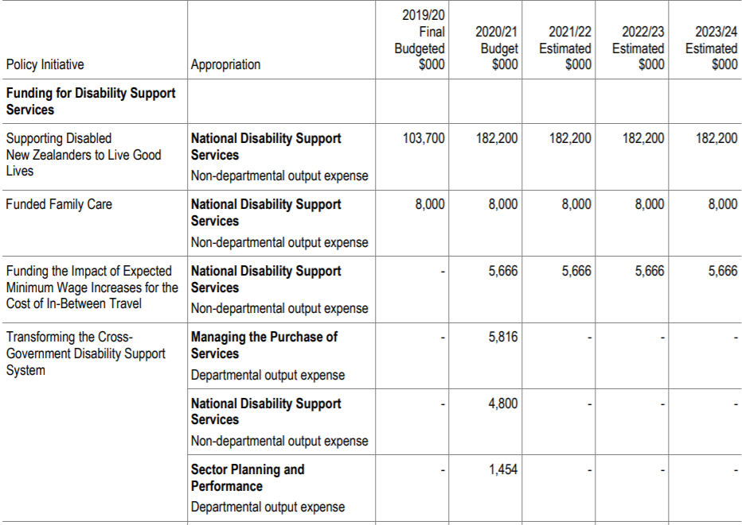
There are some small cuts, which appear to be the product of operational experience, not policy direction:
- $8m reduction in Disability Support Services - Additional Support,
- $7.8m reduction in the allocation of devolved Pay Equity funding
- $4.8m reduction in Transforming the Disability Support System

Interpreting these numbers
Budgets usually set a new baseline for spending in the forecast period, rather than laying out the future year on year increases. This can make the numbers misleading because they appear to show no spending increase in the outyears.
In fact, each Budget has a sum of unallocated, spending which accrues each year. This ‘new operating allowance’ is allocated to spending increases each year. The effect is just because a Budget shows a Budget line staying flat in coming years does not mean the Government does not intend to make funding increases in the future.

