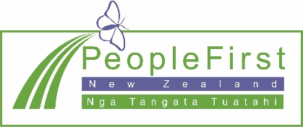
Message from People First New Zealand Ngā Tāngata Tuatahi to all Members
29 April 2020

As you know People First has not been having any meetings while New Zealand has been in Level 4.

We have been thinking about what to do while New Zealand is in Level 3.

We have decided to stay closed while New Zealand is in Level 3.

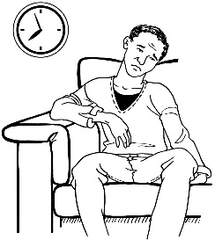
These changes will not be forever.
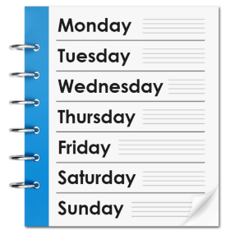
At the moment New Zealand it looks like New Zealand will be at Level 3 for the next 2 weeks.

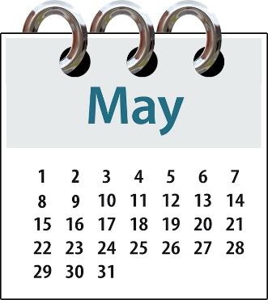
So People First will stay closed until 11 May 2020.

There will be no People First events – like:
- local group meetings

- regional meetings

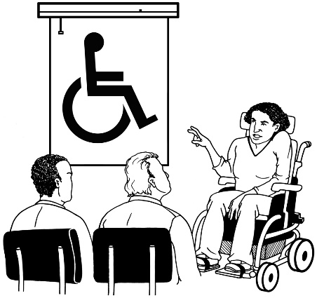
- National Committee meetings

- Money Smarts Made Easy courses

- Keeping Safe Feeling Safe courses.

People First New Zealand staff and Members will not be going to any:
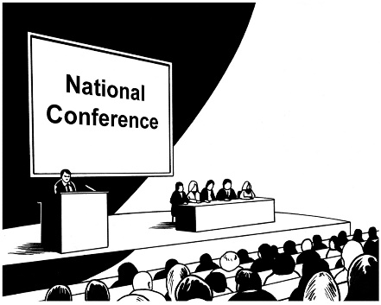
- advisory group meetings

- conferences

- EXPOs.

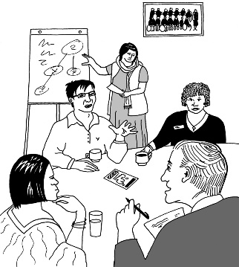
Most events that People First New Zealand had planned to go to have already been cancelled.

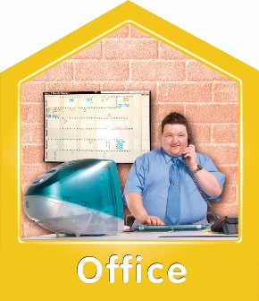
Our offices around New Zealand will stay closed.

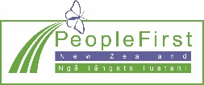
People First staff will keep working from home.

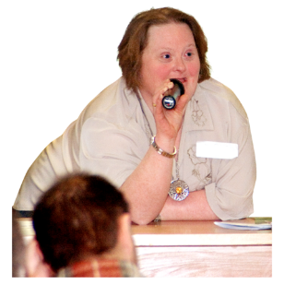
On Tuesday 12 May we will tell you what we are going to do after 11 May 2020.

We know that this is a hard time.

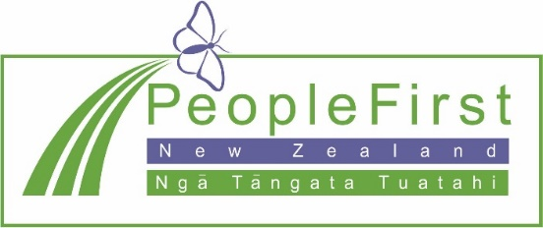
If you need help you can call us on the People First New Zealand helpline.

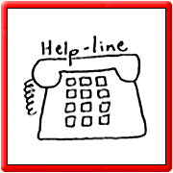
The helpline phone number is:

0800 20 60 70

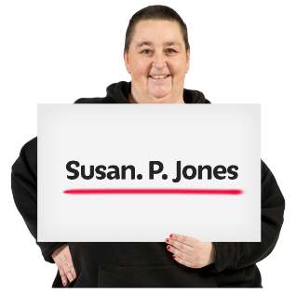
You will be asked to leave a message with your:

- first and last name

- phone number.

It will not cost you any money to call this number.

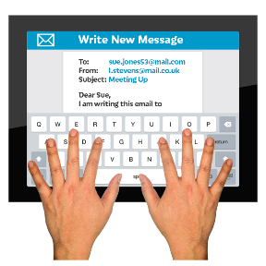
You can also email People First New Zealand on:

ask@peoplefirst.org.nz

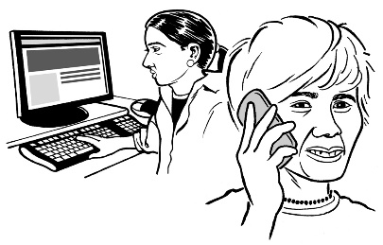
A People First worker will call or email you back.

You can find lots of Easy Read information about COVID-19 on our:
- website
www.peoplefirst.org.nz

- facebook page www.facebook/peoplefirstnz

Stay well everyone,

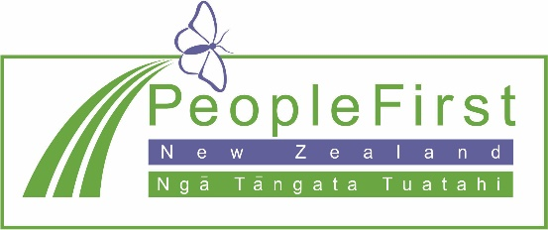
From:
- People First New Zealand National Committee

- People First New Zealand staff

