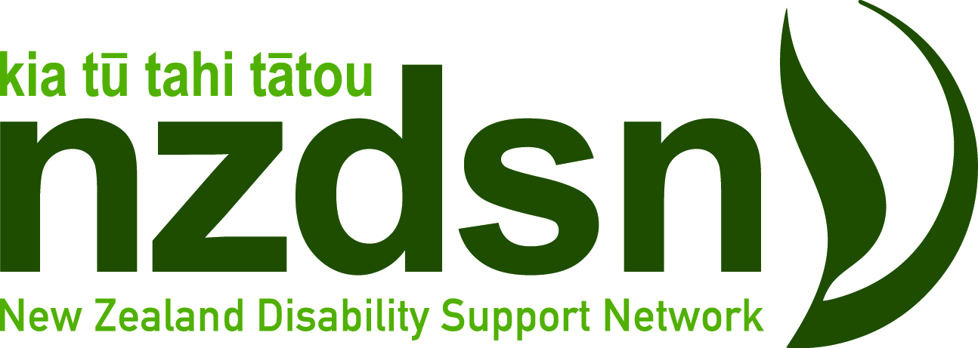

Lower North Island Regional Networking Meeting

Thursday 2nd April
Hohepa Kapiti

Riverside Studio Building
29 Pitoitoi Street, Paraparaumu
10:00am - 12:00noon

This is an opportunity for you to participate in our networking meeting and a great opportunity for local providers to connect and network with others in the Lower North Island and Wellington regions.
Agenda
- Welcome and introductions
- A round table of what’s on top
- NZDSN updates
- Community Participation and Transition
- Sector Transformation
- General business

To register online for this free event go to www.nzdsn.org.nz/events
For any queries please email admin@nzdsn.org.nz

