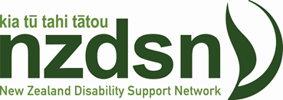
NZDSN National Symposium
Transition from School
“Frameworks for Better Practice”
An opportunity to hear about developments from around the country showcasing effective practice and promising approaches.
March 25th 2020
9.00-4.00pm
Venue: Novotel Rotorua Lakeside, Tutanekai St. Rotorua
REGISTRATIONS NOW OPEN!
Indicative programme:
- Transition from School Collaborations: Making it work in Auckland
- Transition Initiatives and Collaborations: Mana Whaikaha and developments in Mid-Central
- Project Search: A Christchurch internship programme creating employment outcomes
- A family perspective: effective support and engagement with families and whanau
- Implementing new practice frameworks: a panel led discussion (employer, provider, school, parent and young person perspectives)
- Transition and The Disability Employment Action Plan
- The Learning Support Action Plan (Ministry of Education)
Further details coming soon!
To register: Transition from School
Fee: Funding from MSD enables us to offer a subsidised rate of: $150 plus GST
Exhibitors: There will be space available for organisations to exhibit and showcase products and services. Stands available from $175 plus GST. To Register Contact: admin@nzdsn.org.nz

